**No insurance?**

**No problem**

**!**

Our exclusive, affordable dental

savings

plan

allows

you

significant savings on your

dental care

–

without the hassle

of traditional insurance!

**Anderson & Floyd Dentistry**

1906 Edgington Ave

Eldora, IA 50627

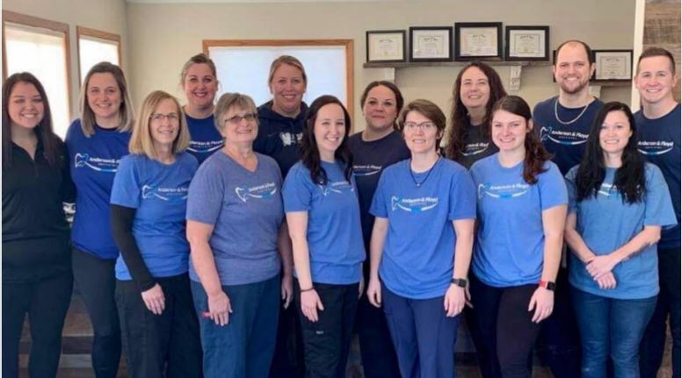

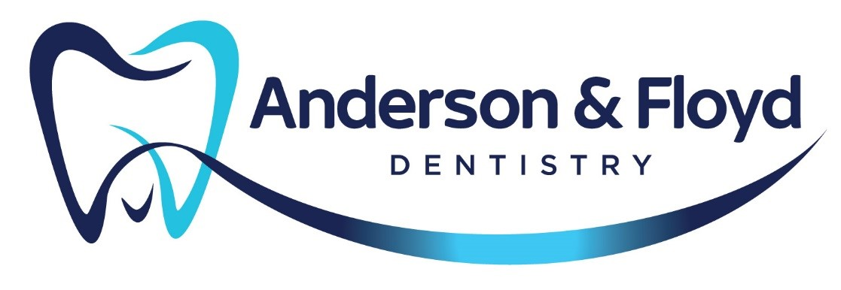

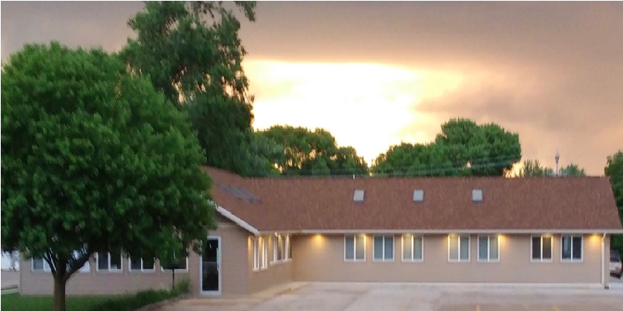

Photo by: Dennis Bartholomew

# AFD Dental Savings Plan

Affordable dental coverage for you and the entire family.

**Dr. Sara Anderson DDS**

**Dr. Kale Floyd DDS**

1906 Edgington Ave

Eldora, IA 50627

641-939-7900

afdeldora.com

# Advantages

* No maximums
* No deductibles
* Pre-existing conditions covered
* No waiting periods
* No treatment limitations
* No fighting insurance companies

# **Everyone is Eligible**



Treatment You Need at

Prices You Can Afford

Our goal at AFD is to help make your dental visits more affordable, so you can get the care you need and want. The AFD dental savings plan gives you the opportunity to receive all available dental services at a discounted fee. **AFD Dental Savings Plan**

## Member $350 Additional dependent $300

Once the annual fee is paid, your membership starts, it allows 12 months of discounted-fee dental services.

## Savings

*10 % discount on All dental services

**Membership includes the following services at no additional charge:**

* 2 Routine exams (once every 6 months)
* X-rays (4 bite-wings, 2 PA’s- once every 12 months)
* 2 Cleanings (prophylaxis, periodontal maintenance, once every six months, twice per calendar year)
* 2 fluoride treatments for children (under the age of 19-once every 6 months)

**The Not-So Fine Print:**

* All payments are due at time of service.
* Valid for one year from date of sign up.
* All dependents must reside in the same household.
* This is not an insurance program, it is a discount plan.
* Plan may not be combined with any other insurance, discounts, or other offers.
* Only valid in this office and for services, not products.

**Anderson & Floyd Dentistry**

1906 Edgington Ave

Eldora, IA 50627

641-939-7900

Afdeldora.com